Compass - On-boarding Process for New Enrolments

Step One:
Student has completed enrolment forms and returned them to the Administration Office (Middle or Senior)

Step Two:
Administration assistant enters the information into CASES/Chess and creates a record for the student, and family, including a CASES number

Step Three:
The records in Compass are regularly updated via CompassLink that uses the Active Directory; meaning that any records in CASES/Chess are automatically added to Compass.

Step Four:
Administration assistant informs the ICT Manager of the enrolment, and they create a Gmail for the student and their family using the CASES record numbers provided to them. The ICT Manager passes on this student email to the Learning Community Leader for the relevant year level, who will pass this onto the student as they induct them on how to use the online tools at the College.

Compass - Off-boarding Process for Exiting Students

Step One:
Student and their family attend an exiting meeting (where possible) with the Learning Community Leader/Sub School Team Leader. Exiting arrangements are agreed to. Part of this discussion is the need to backup any files from school based accounts, such as Google Drive and YouTube. (see handouts on how to do this)

Step Two:
Exit forms are returned to the Administration office (Middle or Senior).

Step Three:
Administration Assistant informs the Learning Community Leader about the students confirmed exit of the College. At this time they also inform the ICT Manager who places an action in their system to disable this student's and family's accounts in 30 days time. The Learning Community Leader meets with student to confirm that they know the process for backing up and saving their work from Google Drive/YouTube/Compass, and prints any reports that may be requested by the family before exiting.

Step Four:
The Administration Assistant disables the CASES account upon exiting. The student's Gmail account will remain open for two more weeks post exiting of the school. After 30 days, accounts will be disabled and access will no longer be available.

Step Five:
If the student or family wish for material to be retrieved from the Gmail account, this can be reactivated within this 30 day period. A meeting with the Assistant Principal is required in order for this to occur.

How to Transfer All Files in Google Drive

Watch this video to learn how to download an archive of your data from your Google account:
https://www.youtube.com/watch?v=OUyXkyUZECw

Step One:
Go to this website, and make sure that you are logged into the relevant Google account in the browser.
https://takeout.google.com/settings/takeout

Step Two
If you only want to download the documents in your Google Drive, click on ‘select none’, otherwise leave all data options on.
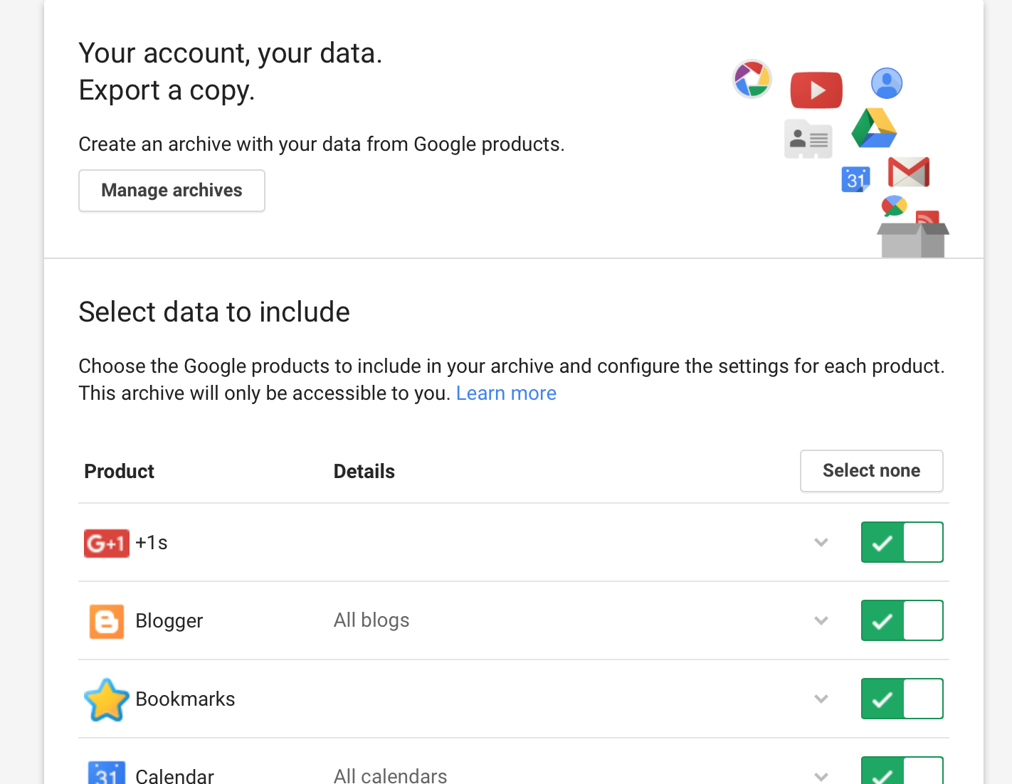

Step Three
If you only want to download from Drive, select this button.
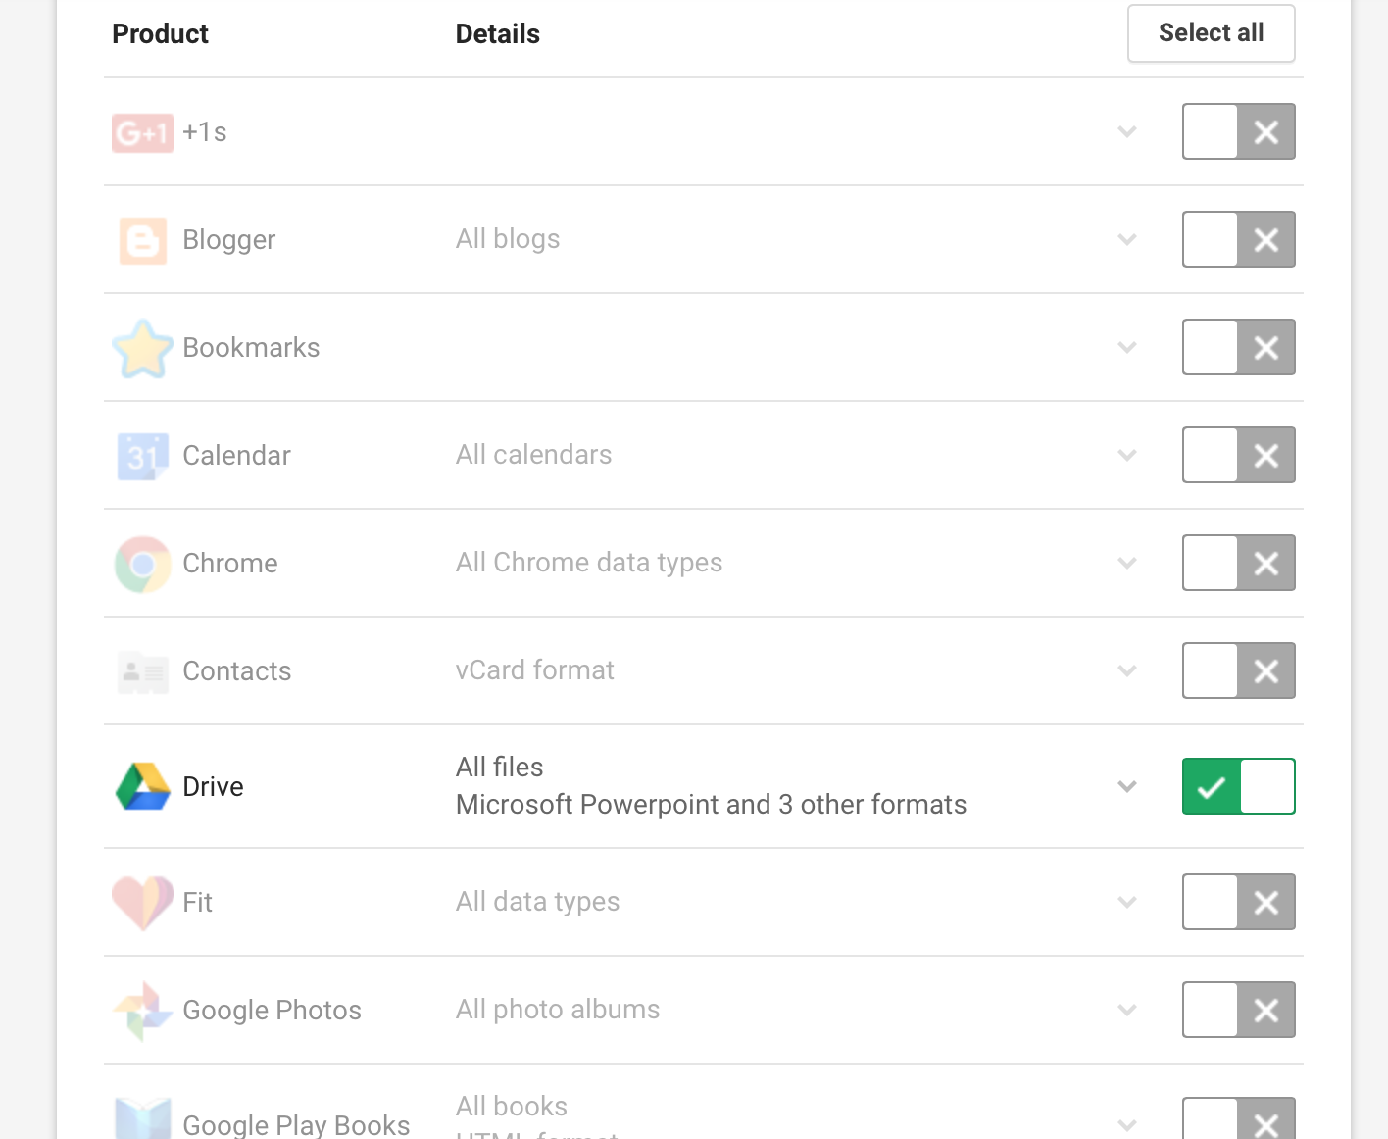

Click NEXT at the bottom when you are ready to download.

Step Four
On the next screen, make sure the option is set to ZIP FILE and ‘send download via email’. There are other options here such as add to drive (alternative account that you have) or DropBox. Select which is most appropriate, but email may be easiest.
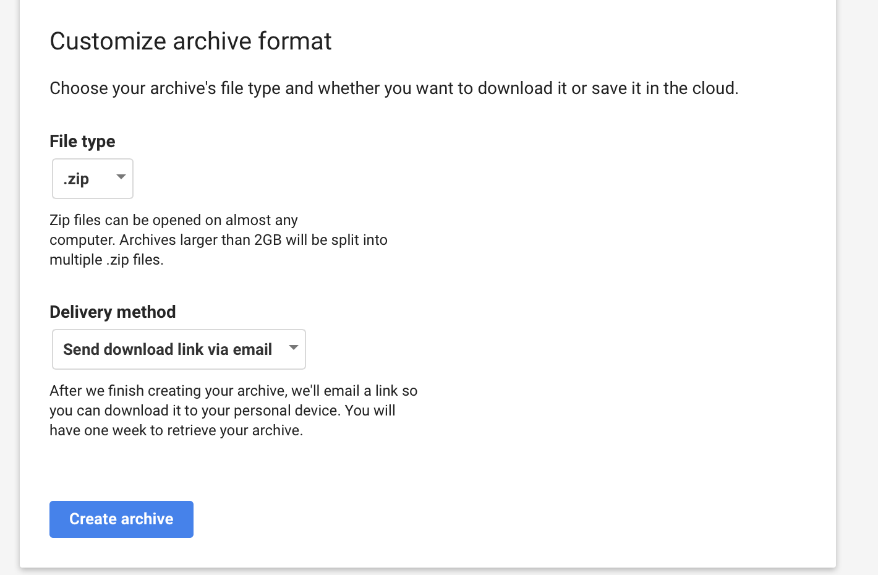

Step Five:
Click on ‘create archive’ and then check your email for the link to the download. Make sure that you download the files and save to your computer before the 30 days is up that you can access your email account.

